Group #1 User Manual
Tower Defense Game
Version: 1.0

Authors: Sejin Kim
Alejandro Pantoja-Zurita
Alejandra Torres-Galvan
Connor Beachy
Raheem McGowan

School: Delaware Technical Community College
Class: CSC 214: Computer Science III
Instructor: Tianzhong Ding

Preface
Version | Date | Version Description
1.0 | 11/30/25 | User manual created.

Table of Contents
- Introduction 4
  - Purpose 4
- Quick Start Guide 4
  - Game Install 4
  - New Game & Level Select 5
  - Controls 6
  - HUD/ Interface Guide 6
- System Requirements 8
  - Supported Operating Systems 8
  - Installation Requirements 8
- Main Scenarios of Use 9
  - Adjusting Game Settings 9
  - Pausing, Restarting, & Resuming Game 10
- Towers & Enemies 10
- Towers 10
- Enemies 10
- Troubleshooting 11
  - Game Won’t Start 11
  - Towers Can’t Be Placed 11
  - Upgrade Panel Not Appearing 12
- Glossary 13
- About 14

Introduction

Purpose
- This User Manual provides instructions for playing and understanding our team's Tower Defense Game developed in the Godot game engine. It is designed for both non-technical users (players) and technical users (developers or maintainers). No prior knowledge of tower defense games is required to engage in this application.

Quick Start Guide

Game Install
- After downloading the game, locate the game folder.
- Simply double-click on the “Tower Defense Game.exe” file to launch the game.
- You will see the Main Menu.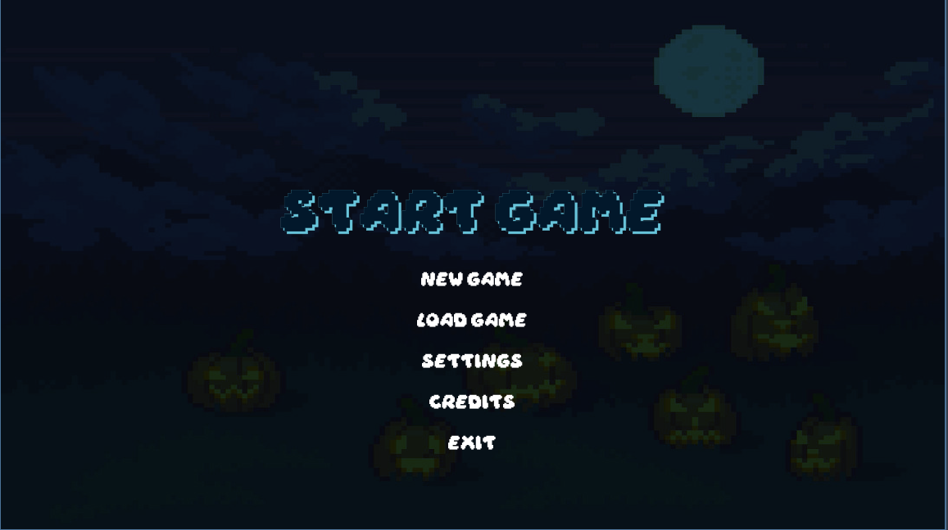

New Game & Level Select
- Click New Game.
- The game will load a new screen in which the player will be prompted for a name
- Type in the desired name and click Confirm.
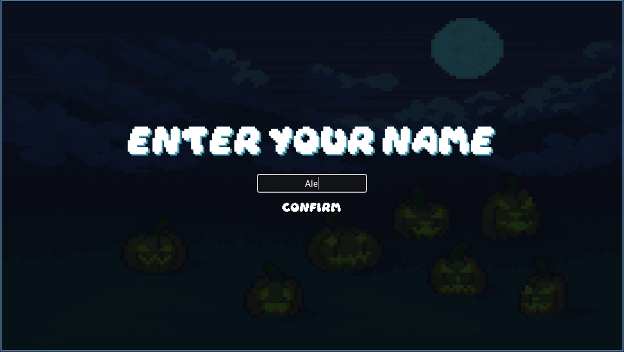
- The game will load the level screen.
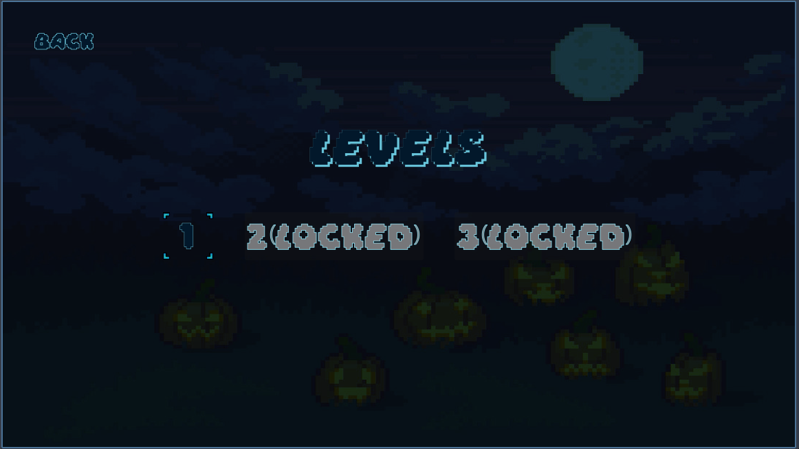
- You will see Levels 1, 2, and 3. For new players, only Level 1 will be available until the rest are unlocked.
- Click on Level 1 to start the 1st level.
  - Controls
- A mouse is required to navigate the menus and the individual levels.
- Left Click: Place / Select Towers.
  - HUD/Interface Guides
- When playing a level of the tower defense game, you will see multiple things on the screen.

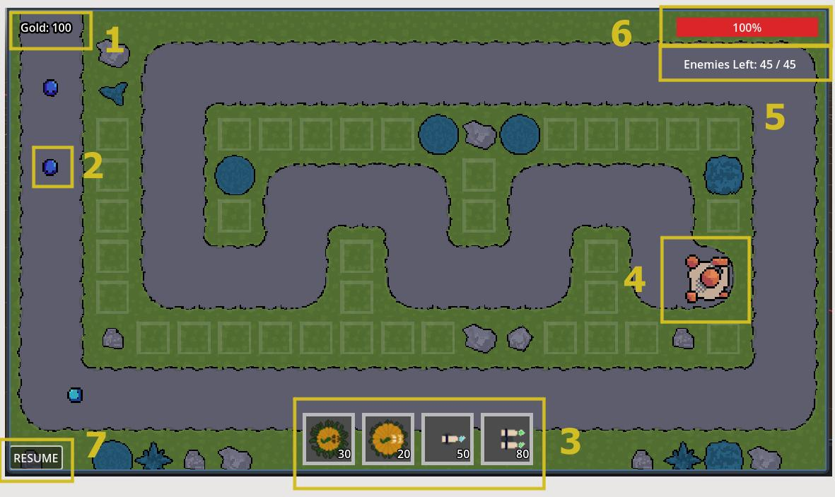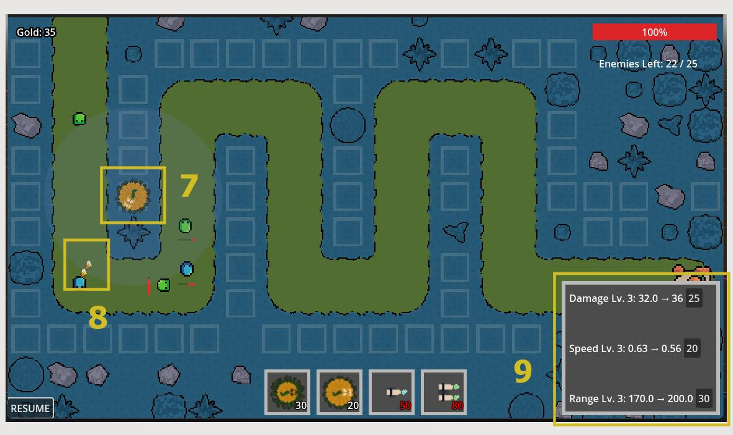
- Gold - Reflects the user's current gold availability.
- Enemies - Stop them from reaching the base (4)
- Tower Menu - Select towers from the menu and place them onto the map to defend the base from enemies.
- Base - Enemies follow a set path towards the base. Damage is taken when enemies reach the base.
- Enemy Counter - Reflects the number of enemies for the level
- Health - Reflects the health that the player currently has. The player loses health when the enemy attacks the base.
- Pause/ Resume Button - Used to pause/ resume the game while in a level.
- Tower - Used to defend the base from the enemies. Can only be placed on the square tiles.
- Projectile - Towers defend the base by firing projectiles at enemies.
- Upgrade Menu - Appears when a player clicks on a tower that has been placed on the map.

System Requirements

Supported Operating Systems
- Windows 7 or later
- macOS 11 or later
- Linux (64-bit)

Minimum Hardware Requirements
- Input Devices: keyboard & mouse

Installation Requirements
- Ability to unzip or extract a zip file
- Permission to run executable files on the device.

Main Scenarios of Use
  - Adjusting Game Settings
- In the Main Menu, the Settings options should be the 3rd button down the list. Users may want to adjust their gaming experience and can do so using this option.
- Settings include:
  - “Music” - Increase/decrease audio volume to the desired level
  - “SFX” - Increase/decrease sound effects volume to the desired level
  - “Resolution” - Adjust the size of the screen. Choose between the window (x1152) or full screen (1920)
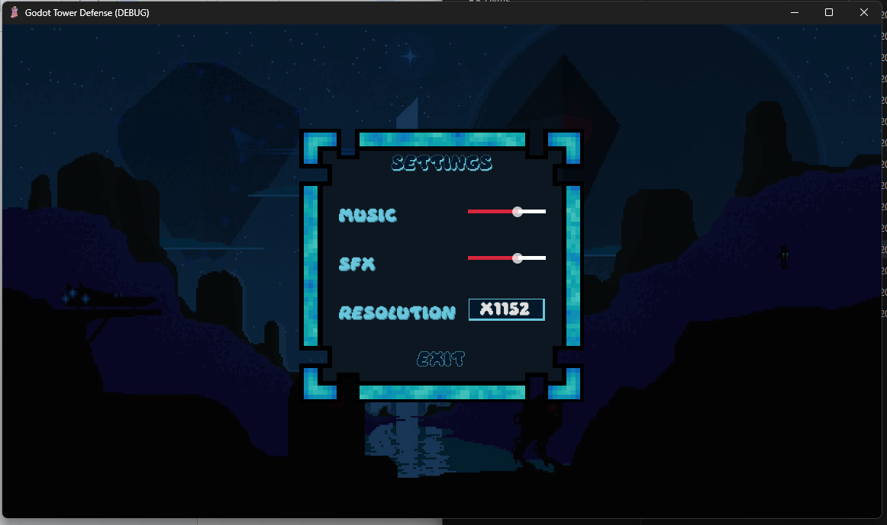

  - Pausing Game & Changing Speed
- During a gaming session, players may want to momentarily stop the session or accelerate it. One can do so by accessing the lower left buttons during gameplay, which will display the following options:
- Pause the game to stop the session
- Resume the gaming session
- Increase/decrease the speed of the session (The Speed at which enemies and towers operate will decrease or increase)


Towers & Enemies

Towers
- There are (4) types of towers that the player can use to defend themselves against the waves of enemies. Each Type is stronger than the last; they are organized as follows from weakest to strongest.
- Small Pumpkin: Large Pumpkin: Flamethrower Mk I: Flamethrower Mk II:
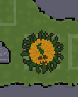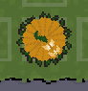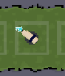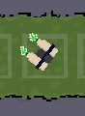

Enemies
- Slimes are the types of enemies the player is defending their base against. There are (5) types of slims that the play encounters throughout the game. Each Type is stronger than the last, they are organized as follows from weakest to strongest.
- Green Slime: Light Blue Slime: Dark Blue Slime: Red Slime: Black Slime:


Troubleshooting

Game Wont Start
- Ensure that the “Tower Defense Game.exe” file has been downloaded and is located in the root folder to correctly launch the game; otherwise, there will be a problem when navigating the menus in the game.

Towers Can’t Be Placed
- Towers may only be placed on available tower slots within the game, as denoted by the square icons below. Ensure that when attempting to place towers, they are in one of the following slots, as shown:


Upgrade Panel Not Appearing
- Upgrade panels are toggled on when clicking on a tower. Check the bottom right of the screen for the upgrade panel. When a tower is selected, a radius will surround the tower, noting its range.
Tower not selected:
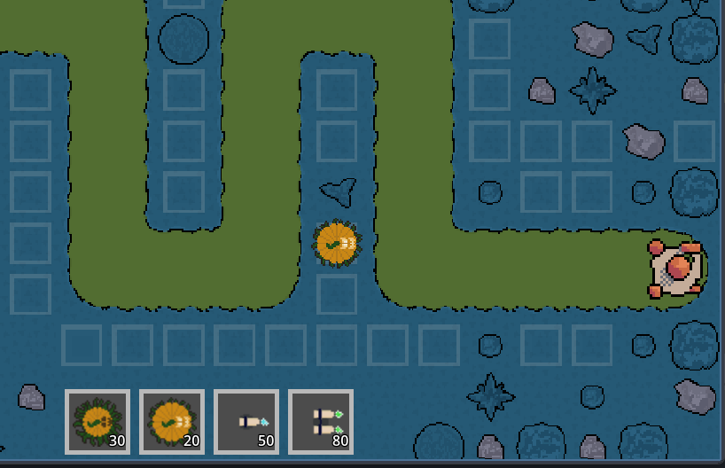
Tower Selected: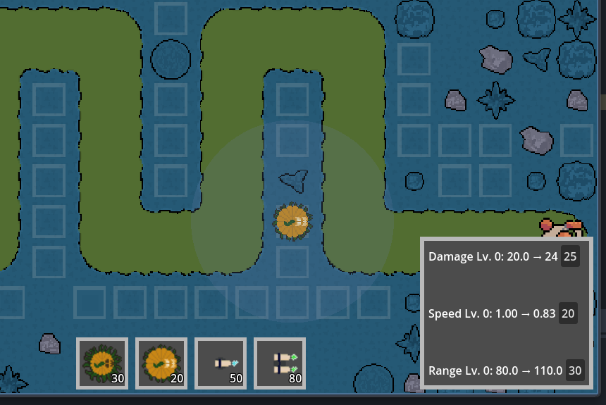

Glossary
- Attack Speed - The amount of time a tower must wait before firing again.
- Damage - How much health a tower removes from an enemy with each attack.
- Enemy Wave - A group of enemies that spawn together.
- Health (HP) - How much damage an enemy can take before being defeated.
- Path - The route enemies follow from their spawn point to the goal.
- Range - How far a tower can reach to attack enemies. Shown as a radius around a tower when a tower is selected.
- Tower - A structure that the player can place in specific locations that will attack enemies and stop them from reaching the base.
- Wave - A group of enemies that are released together with a break between waves. It can also be known as a “Round”.
- Upgrade - An improvement to a tower that increases its stats.
- Gold - In-game resource that players earn by defeating enemies and can spend to place or upgrade towers

About This Game
- This Tower Defense game was created as a group project for CSC 214: Computer Science III at Delaware Technical Community College. The goal of this project was to design and implement a functional prototype of a video game using the Godot game engine. Players are tasked with preventing waves of enemies from reaching the end of a winding path by placing towers and upgrading them to defend their base. This manual is designed to accompany the game, providing users with an understanding of the controls, mechanics, and features within the game. The game was created during the Fall 2025 semester by group #1 as assigned by Mr. Ding.
- Special Thanks to the Godot Engine Community for providing references for how to create a video game. Open-source creators for allowing the implementation of assets to be used for educational purposes, and all members of Group 1. The project proved to be a valuable learning experience.

